(Approx. 1040 words)

Power Basics
By Dick Maybach, Brookdale Computer User Group
www.bcug.com
n2nd (at) att.net

Electrical power is remarkably reliable, especially considering that much of the system is exposed to the elements and sometimes wildlife. On the rare occasions when it does fail, it will be helpful if you know a bit about it. Troubleshooting by candlelight is seldom quick, and ignorance won't make it faster.

You may have noticed that electric power enters your home on three wires. Two of these, which we'll call "Phase 1" and "Phase 2," carry 110-V AC, and the third is neutral. Figure 1 shows the waveforms on the "hot" wires; the voltage on the neutral wire is always close to zero.

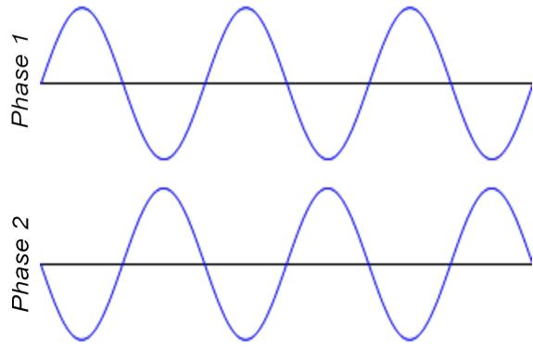

Figure 1. A-C Power Waveforms.

A 110-volt outlet connects to either phase 1 and neutral or phase 2 and neutral. For example, an appliance needing 220 volts connects to both phase 1 and phase 2. Since phase 2 is the negative of phase 1, such a connection applies twice the voltage to the appliance as that between one of the phases and neutral. Thus, although some devices may need 220 volts, the maximum voltage in your house is 110. By the way, if you measure the voltage, you will find it's about 125. When electric power was first developed, it was 110 volts, but that label is no longer accurate.

Figure 2 shows a portion of a home breaker box, which is the interface between your outlets and devices and the power company. At the top is the master breaker through which all the individual circuits connect. Turn this off to remove all the power in your house. Below are the breakers for the individual circuits. If your home is new, there is probably a sheet on the breaker box cover that lists what each breaker controls. In older houses, this sheet is often out-of-date or even missing. Note that the two top individual breakers are actually two individual ones; these are for 220-volt service. As you go from top to bottom, alternate breakers connect to phase 1 and phase 2. Thus, as breakers are added, the loads on phase 1 and phase 2 remain approximately equal, and adjacent breakers can control 220-volt circuits.

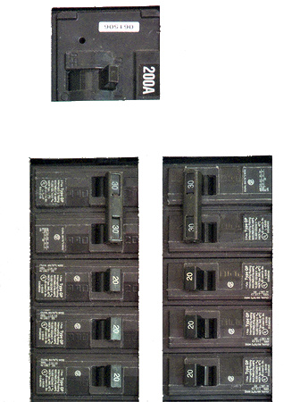

Figure 2. Residential Breaker Box.

There are two types of 110-volt outlets in the U.S., as shown in Figure 3, but the two-wire one is usually found only in older houses.

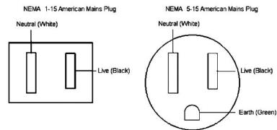

Figure 3. U.S. 110-volt Power Outlets.

The live slot connects to either phase 1 or phase 2 of the incoming power, and neutral connects to neutral. Ground does not connect to the power company but to a good earth ground in your home, typically the incoming water pipe.

You need an adapter between a 3-wire plug and a 2-wire outlet. If you use one, be sure to connect its ground wire to the screw that secures the outlet cover plate. If you have any doubts about your wiring, testers such as the one in Figure 4 are inexpensive insurance. As you can see from its label, the indicator lamp's pattern shows the outlet's state. It's also helpful during the first step of PC troubleshooting, ensuring it has electrical power.

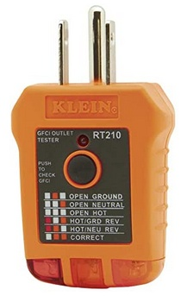

Figure 4. AC Outlet Tester.

You can also use an inexpensive multi-meter to check the voltage at an outlet, but be careful when you insert the probes into the slot; touching 110 volts is always unpleasant and can be lethal. Non-contact testers avoid this hazard, but user reports indicate they aren't reliable.

If a circuit breaker trips repeatedly, either it's defective or the circuit is drawing too much current. Never replace it with one with a higher rating, as the wires in your house are sized to carry currents only up to the breaker rating. In Figure 2, for example, the wires in the 30-ampere circuits are thicker than those in the 20-ampere ones. If you exceed these currents, the voltage at the outlet will drop, and the temperature of the wires in the walls will rise, perhaps enough to degrade the insulation or even to start a fire. Therefore, any electrical work should be done only by a licensed electrician.

In newer homes, some outlets are protected by a Ground Fault Interrupter (GFI), most often in kitchens, bathrooms, and outside the house. Some, particularly those in kitchens and bathrooms, have a distinctive connector, Figure 5.

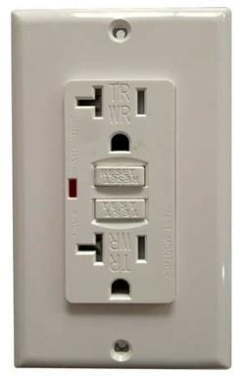

Figure 5. GFI Outlet.

If a GFI detects any current flowing to ground, it trips the breaker. Note the two rectangular buttons in the center; "Test" checks the operation by tripping the breaker, and "Reset" restores power. Usually, each GFI outlet connects to two or three others that don't have distinctive buttons but are also protected. It may be worthwhile to press each test button to see what other outlets are affected. Not all GFI-protected circuits have distinctive outlets. Figure 6 shows a portion of a residential breaker box.

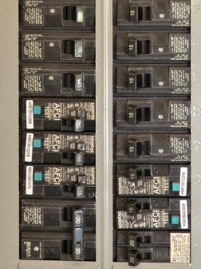

Figure 6. Breaker Box Equipped with GFI Breakers.

Note the green squares labeled "Test" on five of them. These are GFI breakers, but all their outlets are normal, with no test or reset buttons. This is probably because the outlets are near the floor and can be obscured by furniture, making them difficult to access.

It would be worthwhile to become familiar with your home electrical power system while it's working.

- Check which lights and outlets each breaker controls and update the sheet on the breaker box cover if needed.

- If you have an older home, use a tester like the one shown in Figure 4 to be sure the outlets are wired correctly. Use the test button on your GFI outlets to find which are on each circuit.

- If you don't have GFI sockets, consider hiring a licensed electrical contractor to install them, at least in your bathrooms and kitchen.

The most frequent power problem is storm damage, usually repaired within a few hours. Gasoline-powered emergency generators are a common solution here but don't use them near your house because of the carbon monoxide they also generate. It's not uncommon for GFI breakers to trip, which is an excellent reason to become familiar with the circuits they control. I've had standard breakers fail, especially when they are old; in such cases, call an electrician.

